CYBERARK
COMPLIANCE ISSUES
AND REMEDIATION STEPS

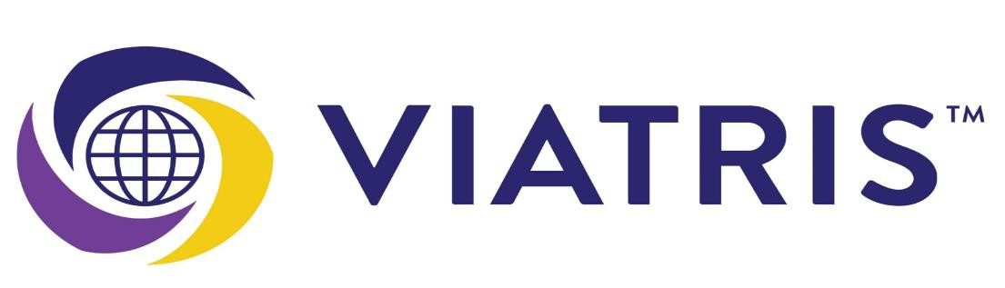

Table of contents

- Purpose
- Scope
- Key Findings
- Remediation Steps
- Post-Fix Status
- Recommendations and preventive actions
- Conclusion

- Purpose:

This document outlines the identified compliance issues and the remediation measures implemented for calogon, carcon, and root users across on-premises UNIX environments, ensuring adherence to organizational security policies.

2.0 Scope:
This document covers the compliance verification and remediation activities performed for calogon, carcon, and root user accounts across on-premises UNIX servers.
The scope includes:
- Validation of user account configurations and access permissions.
- Review of password rotation policies and account expiration settings.
- Identification of non-compliant configurations or security gaps.
- Implementation and verification of remediation actions to ensure compliance with organizational security standards and CyberArk policy requirements.

3.0 Key Findings:
During the compliance review for calogon, carcon, and root user accounts across on-premises UNIX servers.
The following key issues were identified:
- Password Policy Non-Compliance
- Passwords were not rotated within the defined policy interval in CyberArk.
- Some accounts were found with static or manually managed credentials.
- Account Configuration Deviations
- Certain accounts had elevated privileges without proper justification.
- Inconsistent account expiration and lockout settings were observed across environments.
- Missing Account Onboarding
- A few UNIX servers were not onboard to CyberArk, which should be cross checked and onboard the servers.

4.0 Remediation Steps:
The following remediation measures were implemented to address the identified compliance issues and restore adherence to CyberArk and organizational security standards:
- CyberArk Onboarding Completion
- All UNIX servers were onboarded into CyberArk.
- Credential vaulting and rotation policies were enabled for root, calogon, and carcon accounts.
- Verification was performed to ensure proper connectivity between CyberArk and target systems.
- Password Policy Enforcement
- Password rotation schedules were reconfigured as per the defined CyberArk policy.
- Manual credential management was replaced with automated password rotation through CyberArk’s CPM (Central Policy Manager).

  - Fixes:

- Once the request is assigned by the requester, verify whether the servers are onboarded or not. If a server is not onboarded, check whether it is active or retired. If the server is active, proceed with the following checks.

- Login into the CyberArk check the server. (Ex.u3bpnbmep001)
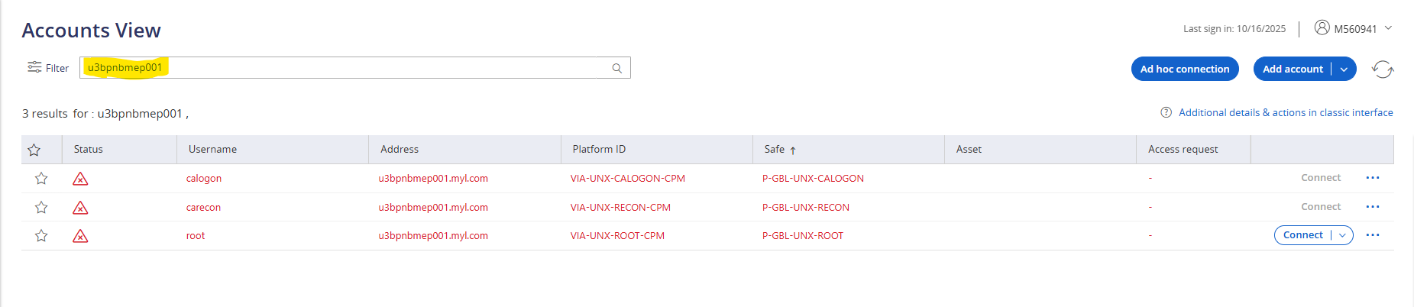
- Verify the error message shown for the users.
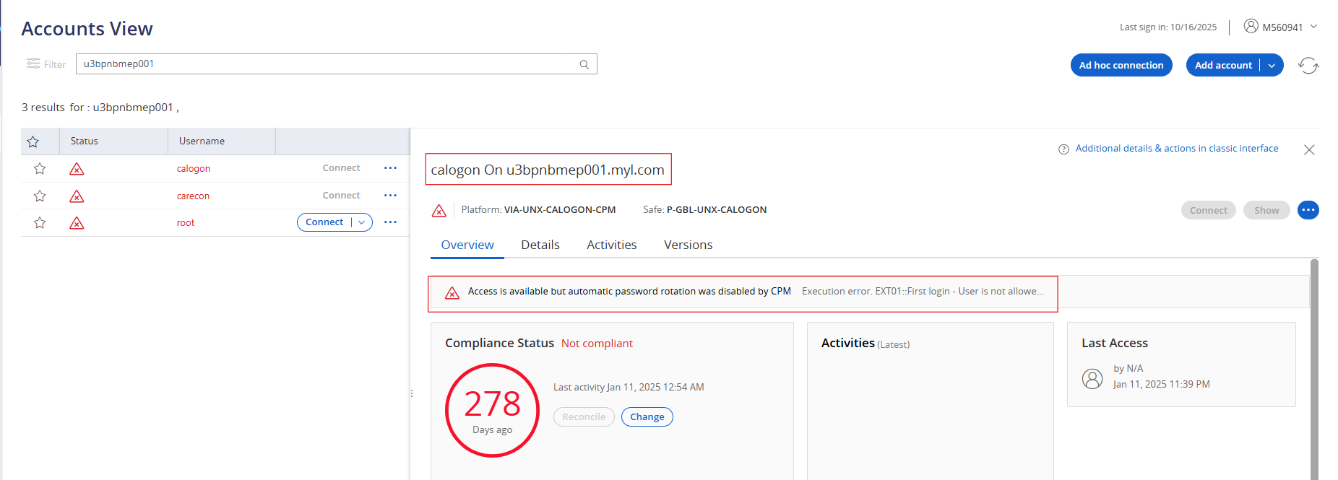
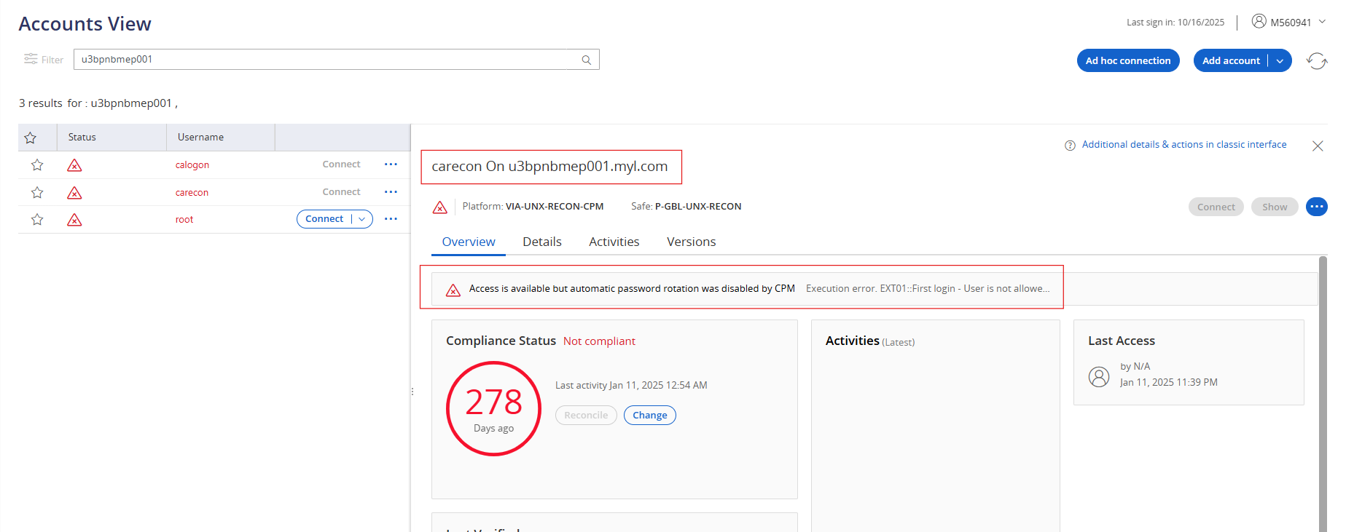

- After verifying the error, initiate a PuTTY session on the server and check whether the users carecon and calogon exist. If the users are present, verify whether they are part of the “CyberArkadm” group. If not, add the users to the group. Once everything is in order, clear any failed login attempts and reset the passwords for both users.

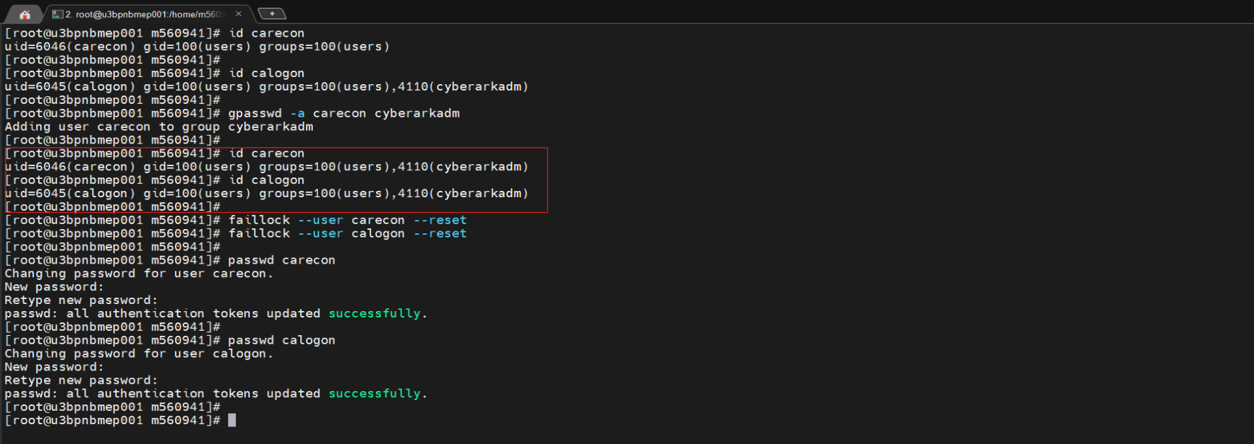

- After changing the password on the server, update the password for the users (carecon & calogon) in CyberArk using the same password.
Note : No need to change the password for root
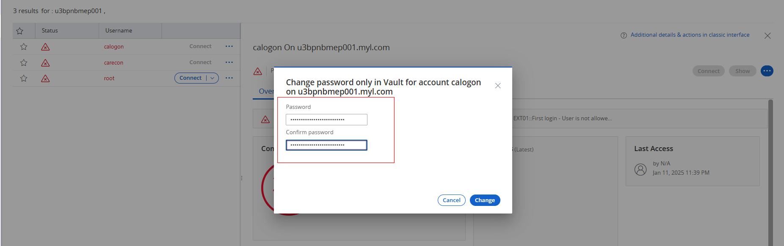

- After changing the password, verify that the compliance status has become compliant.
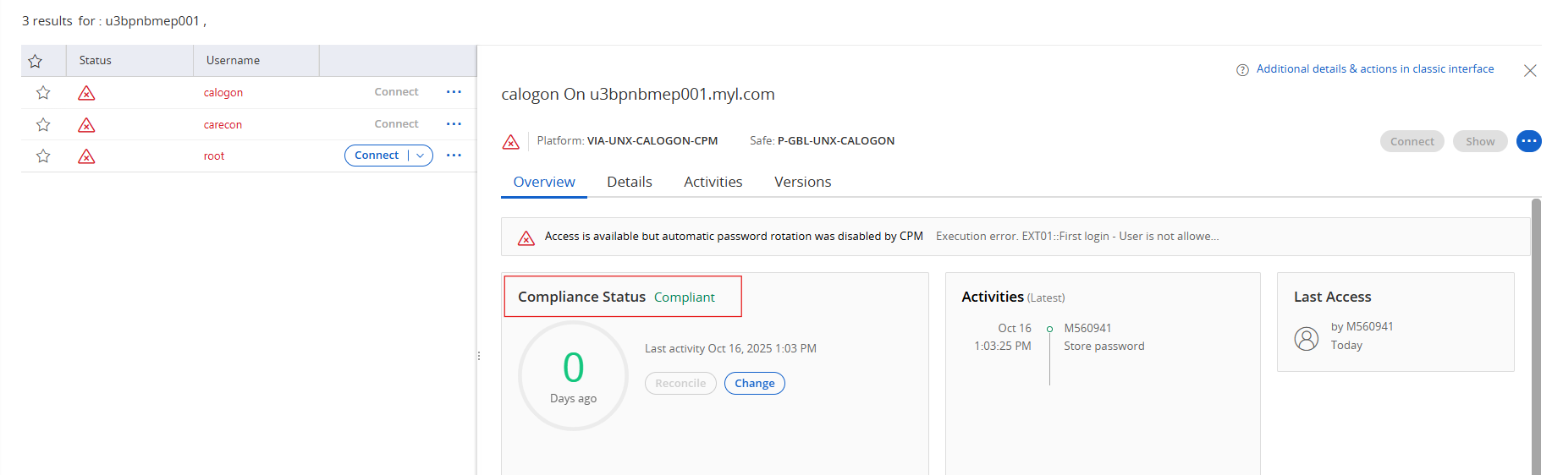

- Select the carecon user and click the Additional Details & Actions icon in the Classic Interface, located at the top-right corner. This will navigate to the account details page.
First, resolve the issue for the carecon user only. Once the carecon user is fixed, the calogon user will reconcile the password automatically after the refreshment.
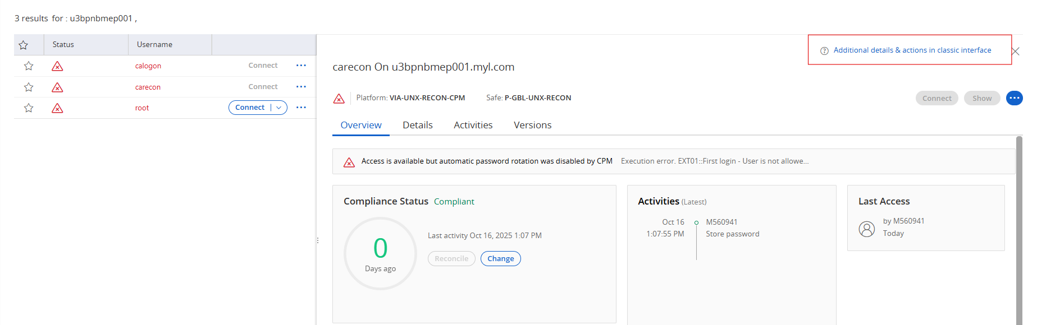

- A. Resume the account.
- Once the account is resumed, refresh it.
- After refreshing, if no errors are displayed, click Verify to verify the account.
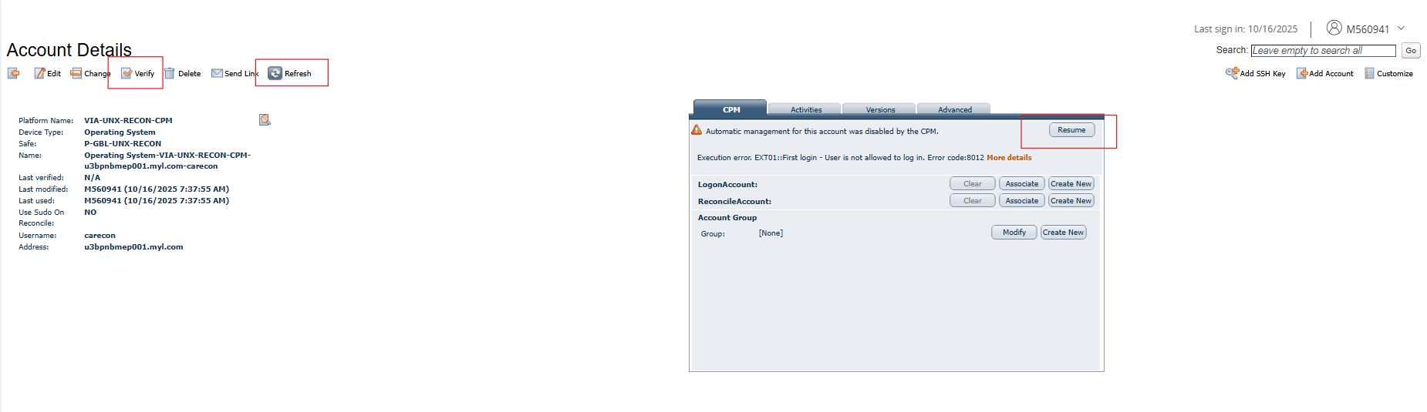
- Make sure no errors are displayed on the account details page under the CPM section.
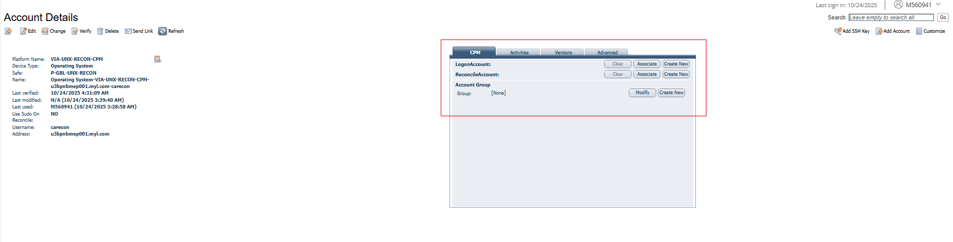
- Return to the main page and verify the server status as shown in the screenshots below.

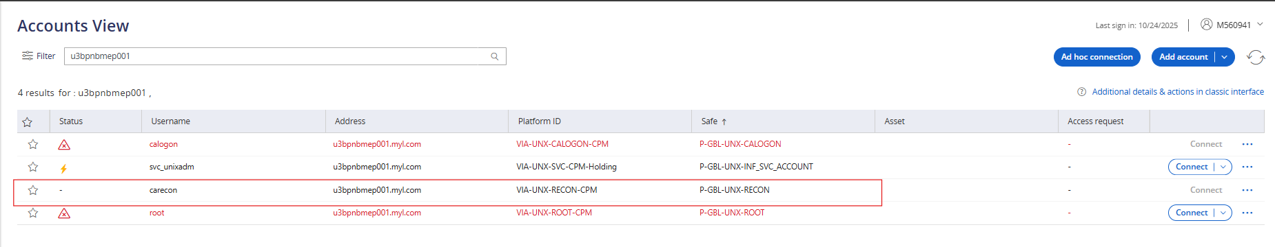
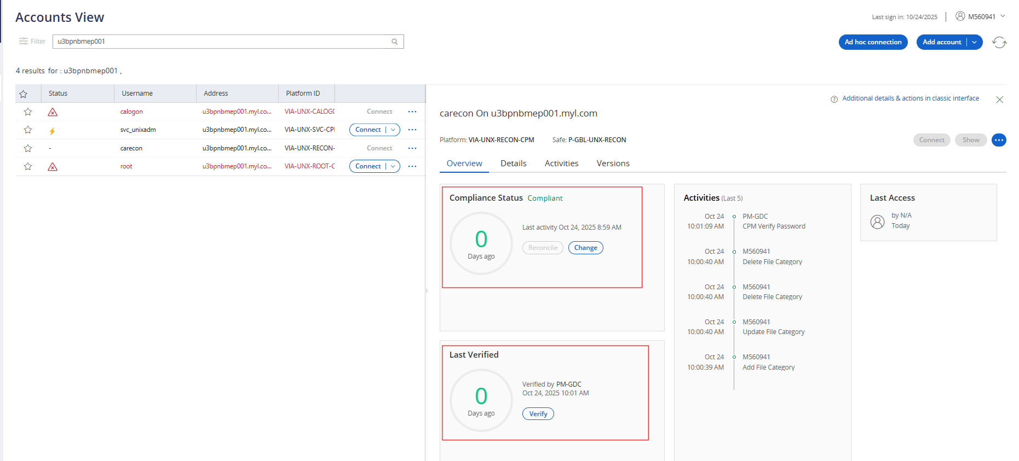
- Repeat the same procedure performed for the carecon user for the calogon user as well. (Follow the step 7,8)
For the calogon user, the reconcile account should be the carecon user, which must be associated with the calogon account.
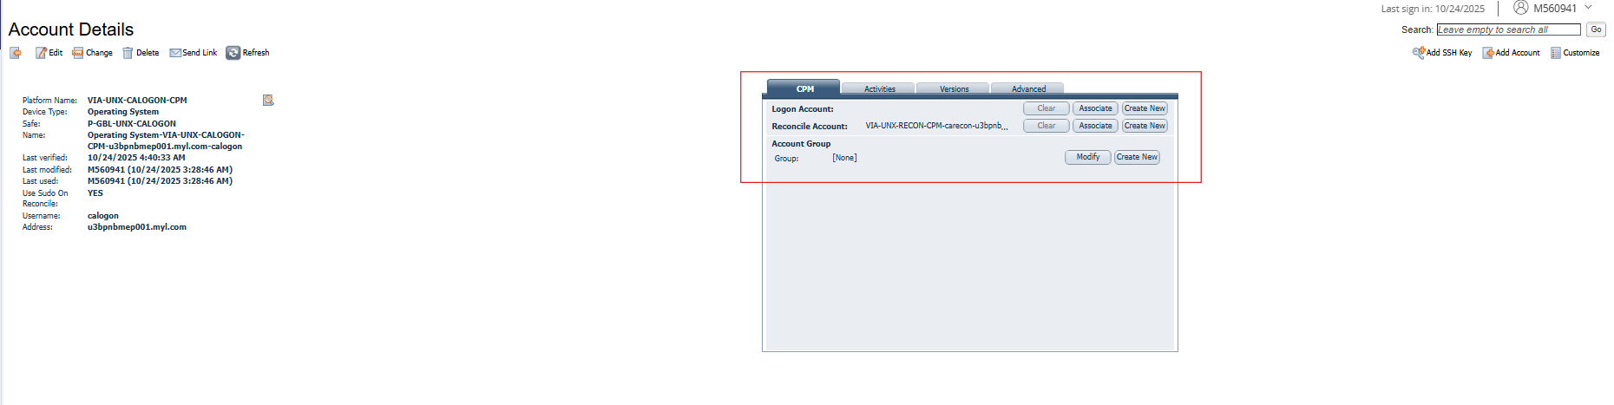
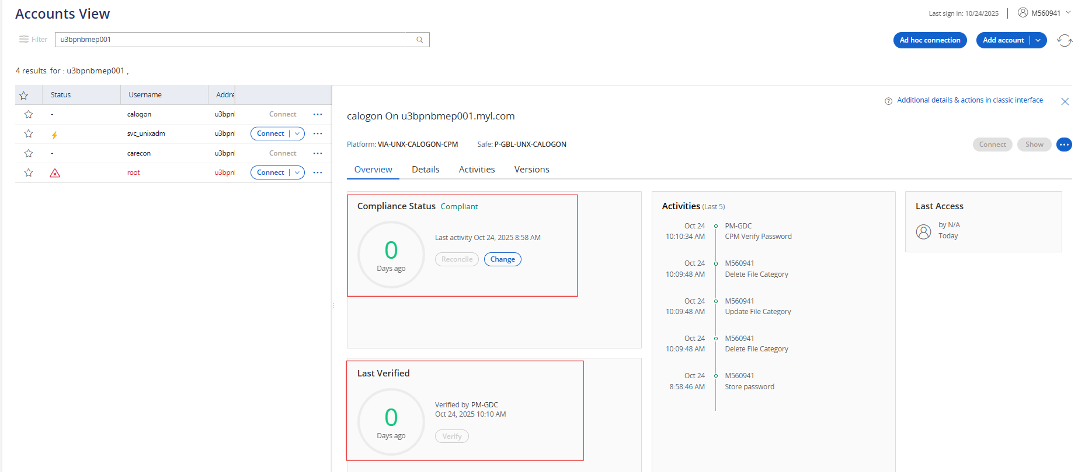

- For the root user, first verify that the reconcile account is associated with the carecon user and the logon account is associated with the calogon user.
If the associations are correct, click Reconcile — this will reconcile the password using the carecon and calogon accounts.
After the reconciliation is complete, click Verify to confirm the password.
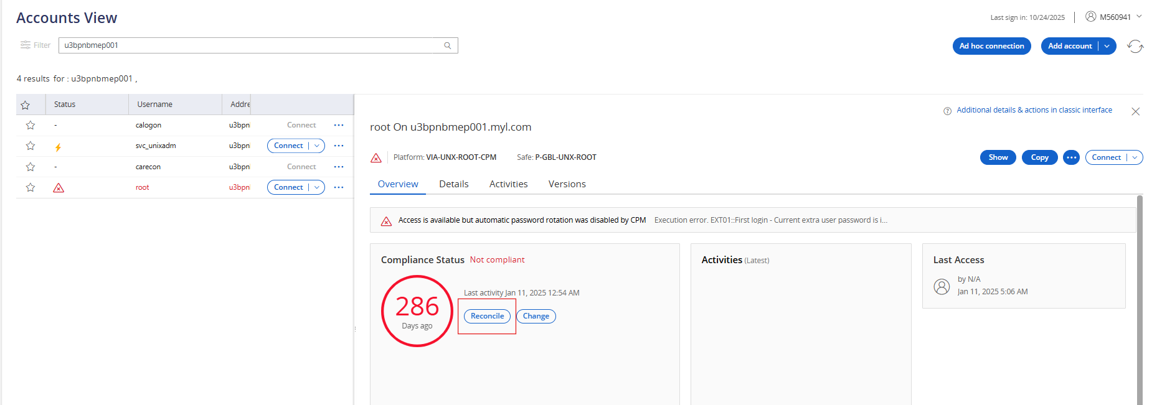

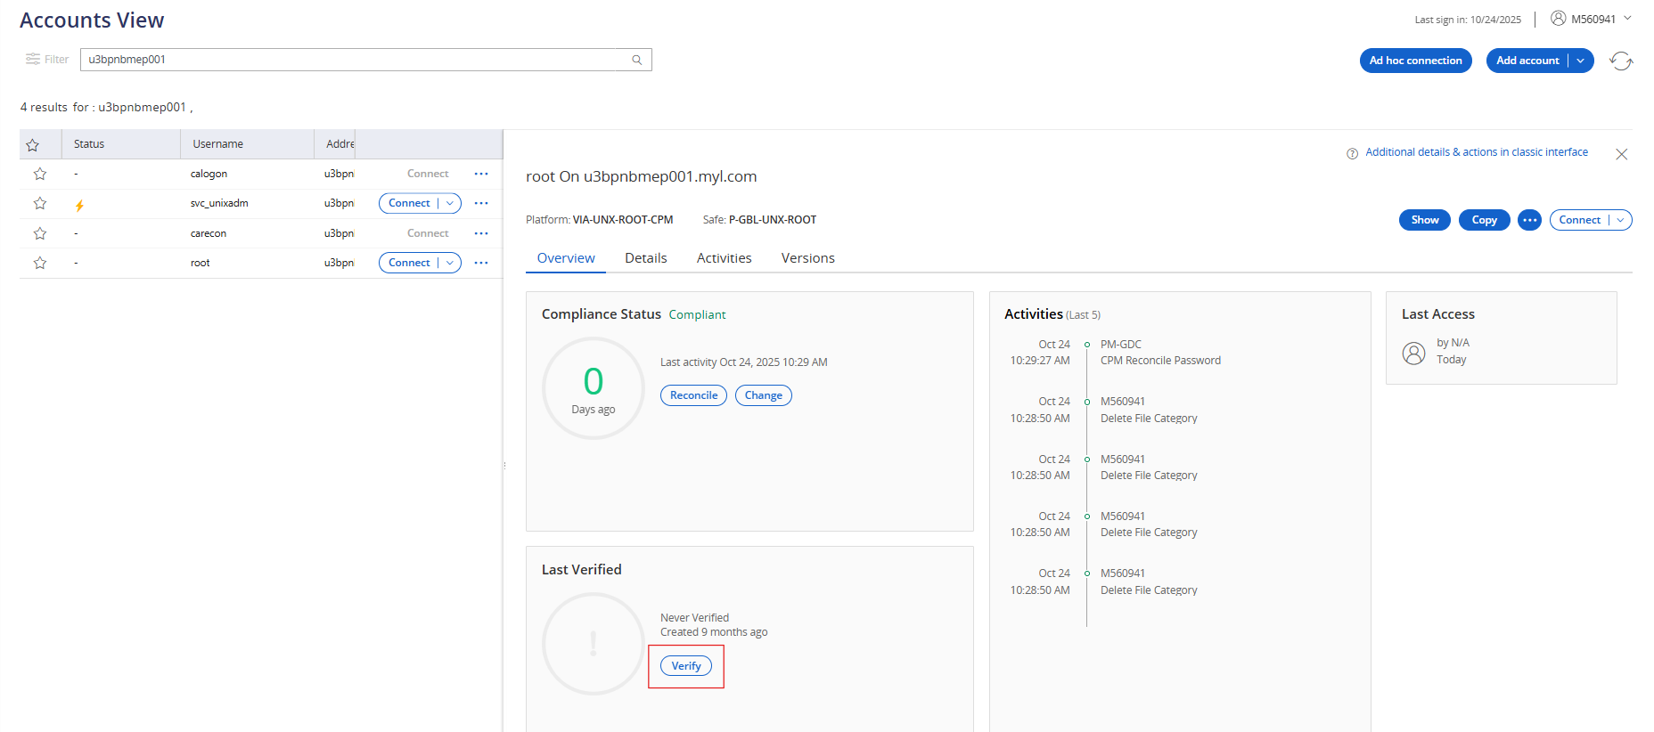

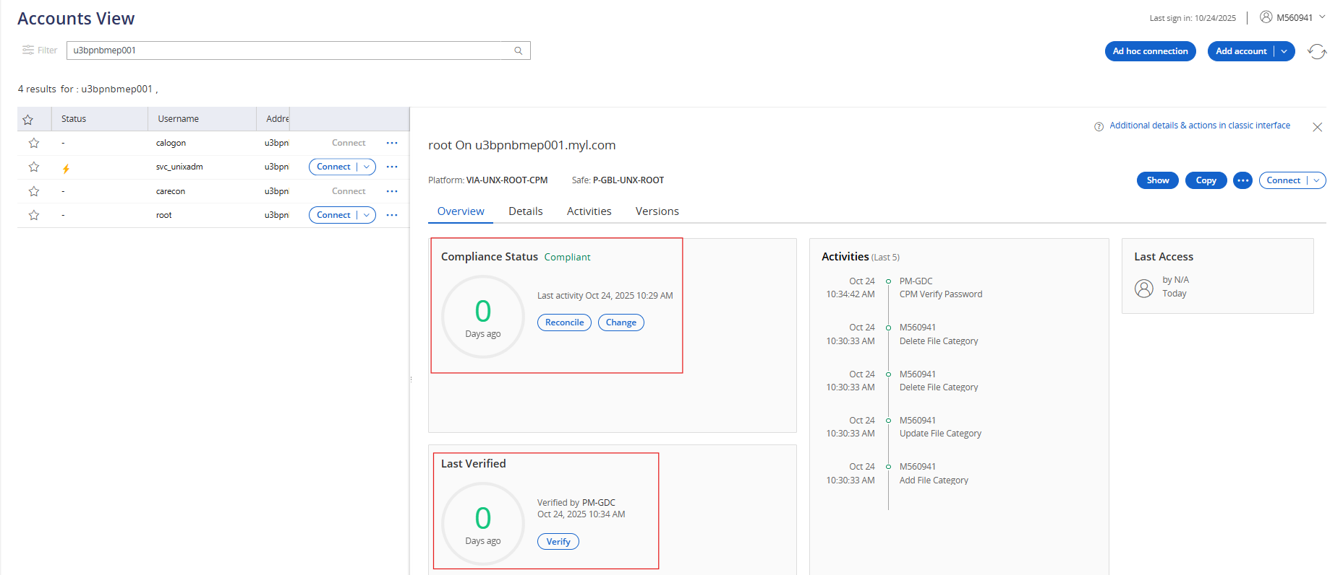

- Once verification is successful, check whether the password rotation is functioning as expected. If the password is not rotating the shown password will show empty.
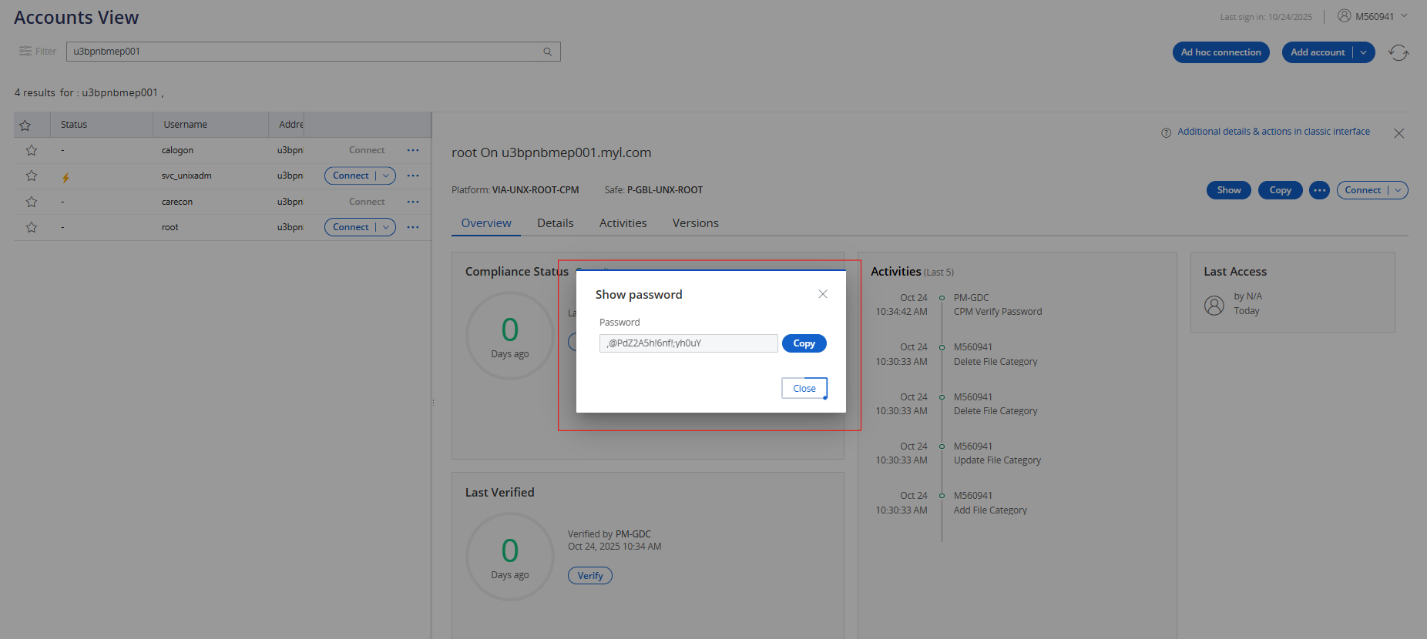

Note: If CPM verification fails and an issue is displayed, refresh the account. If the issue still persists, coordinate with Leslie to enable CPM at the administrative level.

  - Post-Fix Status
Finally, verify that the compliance status for all users is shown as Compliant. The final output should appear as shown in the screenshot below.
Before:
After:
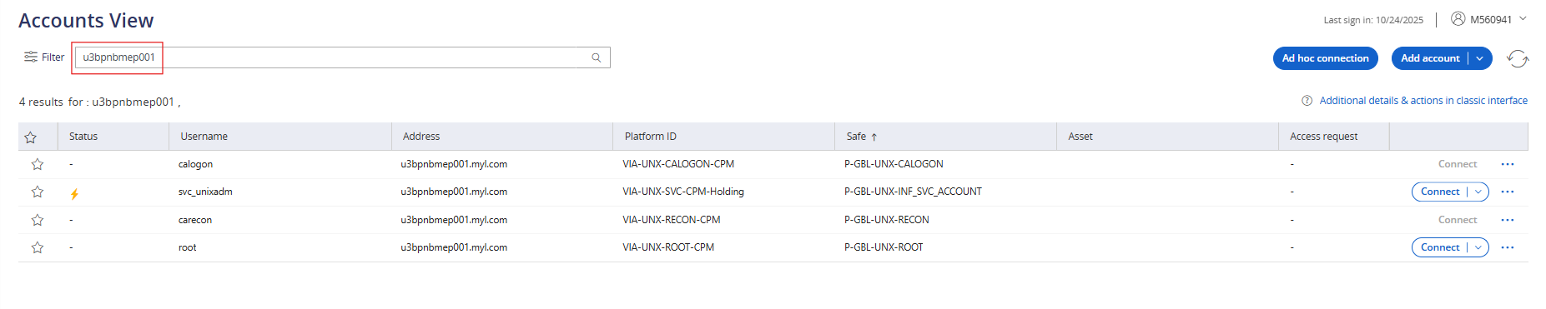
6.1 Recommendations and preventive actions
- Always generate passwords from the CyberArk portal for any administrative activity.
- Manual password resets for the root user should be strictly avoided to maintain compliance and audit integrity
7.1 Conclusion
The remediation activities for the carecon, calogon, and root users were successfully completed across on-premises UNIX servers. All identified compliance issues were analyzed, and corrective actions were implemented to align with CyberArk and organizational security policies.
Post-remediation verification confirmed that all user accounts are now in a Compliant state, with proper account associations, password reconciliation, and rotation mechanisms functioning as expected.

To maintain ongoing compliance, it is recommended to:
- Perform periodic compliance checks and reconciliation tests.
- Ensure all password-related activities are carried out through the CyberArk portal.
- Avoid manual password resets and maintain consistent account group alignments.
This process ensures improved security posture, centralized credential management, and adherence to compliance standards across all UNIX environments.

Date | Version | Summary of changes | Author | Reviewed By | Approved By
24-Oct-25 | 1 | Initial Version | Joshva S | Arun R | Ashok Kumar R K

